LESSON 1
UNIFORM PLANE HARMONIC TRAVELING WAVES
- WHAT YOU WILL LEARN IN LESSON 1:
As engineers, we like to quantify phenomena. In the context of waves, we would like to write an equation representing a wave. Additionally, we would like to assign parameters representing the properties of waves. In Lesson 1, you will learn about the simplest wave type called uniform plane sinusoidal (or harmonic) waves and their properties, i.e., amplitude, frequency and wavelength. The other properties you will learn are phase and group velocities.

- UNIFORM PLANEWAVE (UPW) FUNCTION:
Consider the function
Ф(z,t) = A cos(ωt – kz) (1)
where z and t are independent space and time variables respectively, and A, ω and k are real and positive constants. What the constants A, ω and k represent physically will be derived shortly. We will come to know A, ω and k as amplitude, radian frequency (unit: radians/s) and wavenumber (unit: radian/m), respectively.
The function Ф(z,t) is seen to be a dependent variable which depends on the two independent variables z and t. The easiest way to graphically depict the dependence of Ф(z,t) on z and t is to plot Ф as a function of z or of kz using t or ωt as a parameter. Such a plot is shown in Fig. 1 where Ф is plotted as a function of kz with ωt treated as a parameter.
Fig. 1. Plot of Ф vs. kz for fixed values of ωt
An inspection of Fig. 1 shows that the plot of Ф vs. kz for a fixed value of ωt is simply a cosine curve which shifts bodily without distortion in the +z direction as t ↑. Such a pattern shifting bodily in the +z direction as t ↑ represents a +z propagating or traveling wave. Because the wave pattern does not suffer distortion or attenuation with propagation, this wave is called an unattenuated wave.
We selected a cosine function to represent the wave in the above example but one could equally well have selected a sine function for the same purpose. The sine and cosine functions are really the same function except for a horizontal shift between them of π/2 radians or 90⁰. In other words, a cosine function becomes a sine function when shifted to the right along the kz axis by π/2 radians or 90⁰. Since the first peak point of the cosine function of time appears 90º earlier in time compared to the sine function, one might say that the cosine function leads on the sine function by 90⁰ in time. Equivalently one might say that a sine function of time lags on the cosine function by 90⁰ in time.
Since the argument of the cosine function (or any trigonometric function) must have the unit of radians (or degrees), it follows that the unit of ωt is radians or degrees and likewise the unit of kz is also radians or degrees. Therefore, the unit of ω is rads/s (or deg/s) and likewise the unit of k is rads/m (or deg/m). By convention the unit of ω is always specified as rads/s and the unit of k is always specified as rads/m (or quite commonly but really inaccurately as 1/m). The quantity ω is called the radian frequency for obvious reasons.
A formal defining statement for the period T (or the shortest time it takes for the signal to repeat itself at a fixed observation point z) will be discussed shortly. Similarly a formal defining statement for the period λ in space (or the shortest distance in which the signal repeats itself for a fixed value of t). These defining statements result in the relationships ω = 2π/T and k = 2π/λ. Since time period of the signal is T, it follows that the number of periods/s called frequency f = 1/T (unit: Hz).
What does the terminology uniform plane wave mean? Since the function Ф(z,t) depends on the space variable z but not on x or y (see Eq. 1), it follows that the value of Ф is independent of x and y on any plane z = const., i.e., the value of Ф is constant or uniform on any plane normal to the z direction. As discussed earlier, a wave is a repetitive or periodic pattern in space drifting bodily along the propagation direction. Therefore, as an observer perched on this profile at any point on it moves with the profile, it finds that the value of Ф is the same or uniform at all points on the z = const. plane passing through the perching point on the wave profile. Hence the terminology uniform plane wave. Note that the value of Ф is the same at all points on any one plane but the constant value varies from one plane to another. Any z = const. plane passing through an arbitrary observation point on the moving wave profile is called a wavefront. It should be apparent that there is an infinite number of wavefronts passing through the infinite number of observation points on the moving wave profile, and the constant value of Ф on a wavefront varies from one wavefront to another (see Fig.2).
What does the terminology harmonic plane wave mean? The terminology harmonic plane waves simply means the function Ф varies sinusoidally with z as well as t. Note that, although we chose a cosine (or a harmonic) function to illustrate a traveling wave, it should be apparent that, in general, the periodic function representing a traveling wave can in principle be any function as long as it is periodic in space and time as illustrated in Fig. 3.
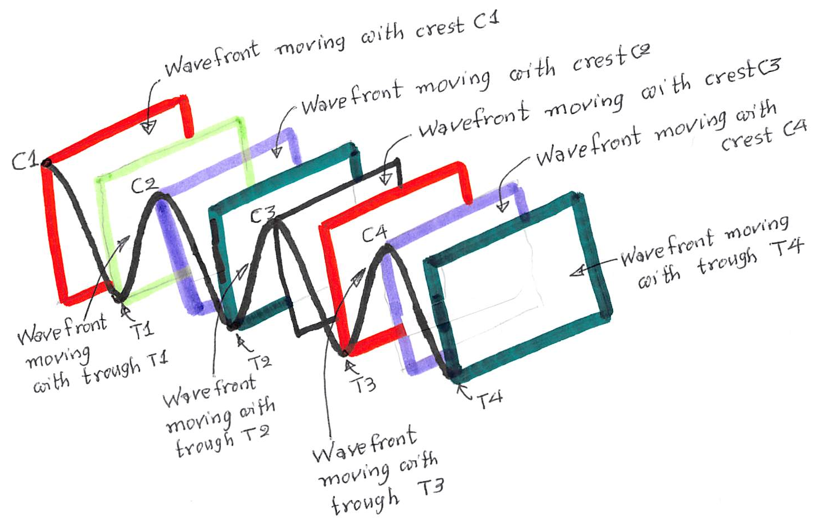
Fig. 2. Plane wavefronts shown at only at the maxima and minima points of a moving sinusoidal pattern. Note that the plane wavefronts can be drawn at any point on the sinusoidal pattern, and that on each uniform plane wavefront the value of the wavefunction is uniform (or the same at all points on the plane).
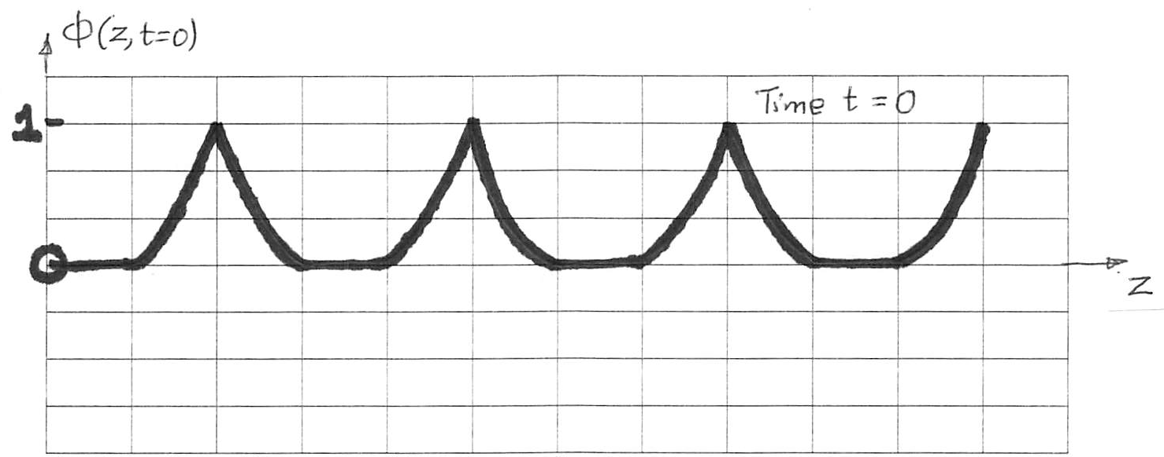
Fig. 3. Illustrating a uniform non-sinusoidal planewave profile.

- DRIFT VELOCITY OF A TRAVELING UPW DERIVED USING A DIMENSIONAL ARGUMENT:
One may rewrite Eq. (1) as
Ф(z,t) = A cos[ω (t – z/v_{p})] (2)
where v_{p} = ω/k is a constant which by dimensional argument represents the drift velocity of the wave. This interpretation becomes apparent if one thinks of an observer perched at one specific point on the wave profile corresponding to a constant value of the argument of the cosine function. Therefore, as t ↑, z (the location on the wave profile where the observer is perched) must also go up. This drift velocity, called the phase velocity, is discussed further shortly.
- UPW TIME PERIOD T:
The time period T of the wave is defined as the shortest time interval at a fixed observation point in space z₀ (say) in which the signal repeats itself (see Fig. 4). The defining statement for the time period T is thus
Ф(z₀,t) = Ф(z₀,t+T) (3)
which yields
cos(ωt – kz₀) = cos[ω(t+T) – kz₀]. (4)
Solving the trigonometric equation (4) using the periodicity property of the cosine function, namely, cos θ = cos(θ + 2nπ), with n = 1,2,3,…, one gets
ωT = 2π (5)
using the smallest value n=1 of n.
T is the time in s for one period (or cycle), hence it follows that the number of periods (or cycles) in 1 s is
f = 1/T (6)
where f is the frequency in cycles/s or simply Hz which is the conventional unit. From Eqs. (5) and (6), one gets
ω = 2πf (7)
The unit of ω is seen dimensionally to be radians/s. For this reason, ω is conventionally called the radian frequency.
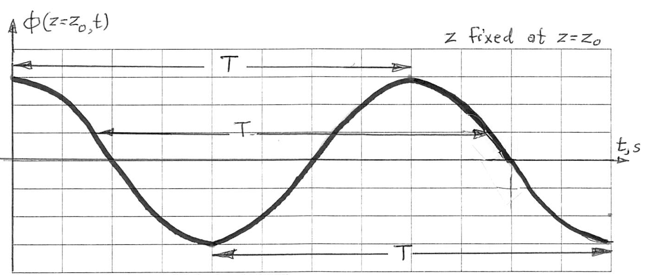
Fig. 4. Illustrating the time period T of a sinusoidal UPW.

- UPW SPACE PERIOD OR WAVELENGTH λ:
The space period or wavelength λ is defined as the shortest distance in the direction of propagation at a fixed time t=t₀ (say) in which the signal repeats itself (see Fig. 5). Thus, the defining equation for λ is
Ф(z,t₀) = Ф[(z+λ),t₀] (8)
Show that Eq. (8) leads to the result
Λ = 2π/k (9)
The constant k is conventionally called the wavenumber, and has the units of rads/m ((or quite commonly but really inaccurately as 1/m).
- AMPLITUDE OF THE WAVE:
The amplitude of the wave is defined as the maximum positive value of the signal Ф(z,t) which is readily seen by inspection to be A which obtains when cos(ωt – kz) = 1.
- -z PROPAGATING UPW:
If one changes the sign of the z term in the expression for the wavefunction in Eq. (1), the wavefunction becomes
Ф(z,t) = A cos(ωt + kz) (10)
which is readily seen to represent a -z propagating wave, i.e., the wave profile moves bodily in the -z direction as t↑.

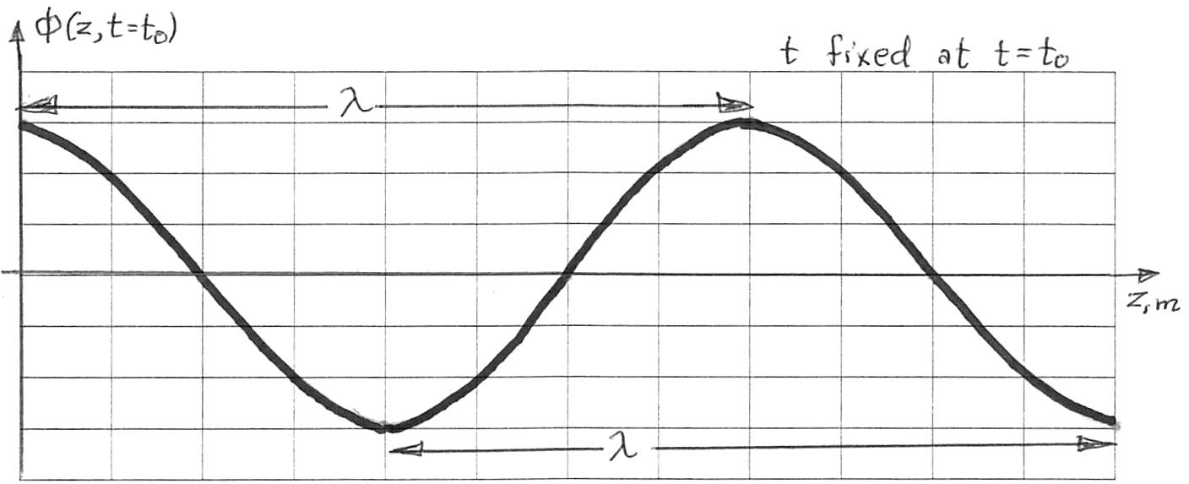Fig. 5. Illustrating the wavelength λ of a UPW
- PHASE VELOCITY:
Let us rewrite the wavefunction as
$Ф\left(z,t\right)=A\cos{θ(z,t)}$ (11)
where
$θ\left(z,t\right)= ωt ∓ kz$ (12)
where $θ\left(z,t\right)$ is called the phase angle or simply the phase of the wave.
The defining statement for the wavefront of the wave is
$θ\left(z,t\right)$ = const. → $ωt ∓ kz$ = const. (13)
i.e., the wavefront is the locus of all points in space corresponding to a fixed or constant value of the phase angle. For a fixed value of t, the wavefront is a plane normal to the z axis given by the equation z = const. As t ↑, this wavefront moves in the +z direction if $θ\left(z,t\right)= ωt- kz$ and in the -z direction if $θ\left(z,t\right)= ωt+ kz$.
It should be apparent that an infinite number of wavefronts exits, each moving with the wave profile and tied to a particular point on the wave profile. This is illustrated in Fig. 2 where the wavefronts tied to the crests and the troughs on the wave profile are shown. All wavefronts move with the same speed as the wave profile.
Differentiating Eq. (12) with respect to t for a constant value of the phase angle $θ\left(z,t\right)$yields
$\frac{d}{dt}θ\left(z,t\right)=0$ → $ω ∓ k \frac{dz}{dt}=0$ (14)
where $\frac{dz}{dt}$ is none other than v_{p}, i.e.,
v_{p} = $± ω/k$ (15)
The + sign in Eq. (15) refers to +z propagation and the – sign to -z propagation.
A physical interpretation of v_{p} is readily obtained by considering the example of a boat riding a water wave. The water wave, as in the case of a UPW, may be looked upon as a sinusoidal pattern drifting in the direction of propagation at a constant velocity v_{p}, with this sinusoidal pattern representing the surface particles of water. Assume now that the boat also moves in the direction of water wave propagation. Clearly the boat must move at a velocity v_{B} equal to the drifting speed v_{P} of the wave in order for the boat to remain at a crest point or at any other point on the wave profile thereby avoiding buffeting (see Fig. 6).
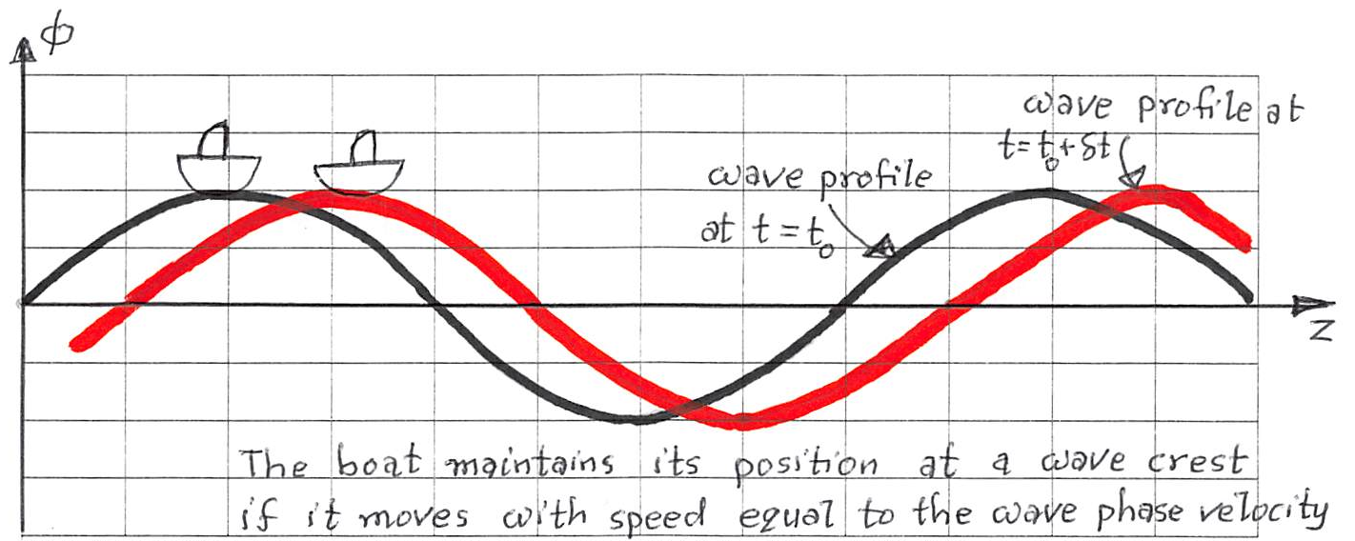Fig. 6. A boat riding a water wave must move with a speed equal to the phase velocity of the wave in order to remain at a crest on the wave as t ↑.
- GROUP VELOCITY:
Phase velocity v_{p} refers to the velocity with which the profile of a single sinusoidal wave shifts bodily in the direction of propagation. A natural question that arises is: what happens to wave propagation when, instead of a single sinusoidal wave, we have a group of waves propagating in the same direction? Superposition of a group of waves leads to an interference or beating process. The simplest case of this interference process happens if the group consists of two waves which have the same amplitude but incrementally different frequencies (and thus also incrementally different wavelengths). The total signal for two such waves is
Ф(z,t) = A cos(ωt – kz) + A cos{(ω+δω)t –(k+δk)z} (16)
Using the trigonometric identity cos A + cos B = 2 cos[(A+B)/2] cos[(A-B)/2], Eq. (16) becomes
Ф(z,t) = 2A cos{[ω+(δω/2)]t –[k+(δk/2]z} cos[(δω/2)t – (δk/2)z] (17)
Since δω << ω and δk << k, one may rewrite Eq. (17) may be written as
Ф(z,t) = 2A cos(ωt –kz) cos[(δω/2)t – (δk/2)z
= 2A cos{ω[t – (z/v_{p)}]} cos{(δω/2)[t – (z/v_{g})]} (18)
where
v_{g} = δω/δk
which, in the limit as δω→0, becomes
v_{g} = dω/dk (19)
and is called group velocity.
An inspection of Eq. (18) shows that the right-hand side of this equation is the product of two wavefunctions, one with frequency ω and the other with frequency δω. The first wavefunction represents the so-called carrier (or high-frequency) wave and the second wavefunction represents the so-called envelope with the lower frequency δω. The effect of interference between the two waves with incrementally different frequencies is the generation of an amplitude-modulated carrier wave or cw signal. This result becomes evident if one writes Eq. (18) as
Ф(z,t) = A’(z,t) cos[ω(t –(z/v_{p})
where the amplitude modulation factor A’(z,t) has the expression
A’(z,t) = 2A cos[(δω/2)t – (δk/2)z]
Or the expression
A’(z,t) = 2A cos{(δω/2)[t – (z/v_{g})]} (20)
which represents a wave of amplitude 2A, frequency δω/2, and shifting velocity v_{g}. A qualitative depiction of the product of two propagating wavefunctions resulting in an amplitude modulated cw signal is shown in Fig. 7.
As indicated in Fig. 7, the cw signal contained within the envelope travels at the phase velocity v_{P} while the envelope travels at group velocity v_{g}. It can be shown that v_{g} represents the speed of energy propagation by the wave. For electromagnetic waves propagating in vacuum, it can be shown that v_{p}.v_{g = c}², where c = 3.10⁸ m/s is the speed of light in vacuum.From relativistic considerations it can be shown that energy propagation by an electromagnetic wave cannot occur faster than the speed, hence v_{g ≤} c and v_{p ≥} c such that v_{p} . v_{g =} c².
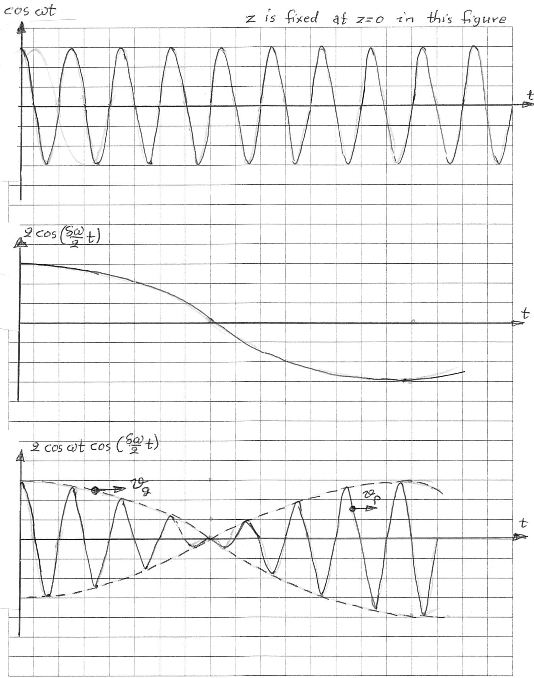Fig. 7. Illustrating the interference between two UPWs traveling in the same direction, with the two waves having the same amplitude and incrementally different frequencies

CONCLUSION:
In this lesson, we learnt that a wave in general is a periodic pattern in space and time which moves in space with a constant velocity called the phase velocity as time increases. A general uniform plane wave (UPW) is fully specified if one knows the values of three wave parameters: (i) wave amplitude, (ii) wave frequency, and (iii) wavelength of the wave. The speed at which the wave profile moves at time changes is called the phase velocity while the speed at which energy is carried by the wave is called the group velocity. When these two velocities are the same, the propagation is called nondispersive. When the two velocities are unequal, the propagation is called dispersive.

